Problem Statement

A year ago in Chicago, the high incidence of crime prompted the government to take decisive action by launching an operation with top-performing police officers. As a year has passed since this decision, the government seeks to evaluate the reduction in crime cases and the advantages gained from this new operation. The government has engaged you as a freelancer data analyst to analyze the changes and improvements in crime rates.  The government is seeking the following objectives from your analysis:

1. If the case-solving time improved
2. What are the localities where the crime rate was higher
3. What can be the measures that can be taken to improve the crimes further

Chicago has grappled with high crime rates, which have posed significant challenges to the safety and well-being of its residents. Recognizing the urgency of the situation, the government took decisive action to mitigate crime and restore confidence in the city's security infrastructure. The implementation of this operation marked a pivotal moment in Chicago's efforts to combat crime and improve overall quality of life for its residents.

**Primary Objectives:**

1. **Assess Improvement in Case Solving Time:** Determine whether the new operation has led to a reduction in the time taken to solve criminal cases, reflecting enhanced efficiency and effectiveness in law enforcement procedures.
2. **Identify High-Crime Localities:** Analyze crime data to identify areas within Chicago where crime rates have historically been higher, highlighting priority areas for targeted interventions and resource allocation.
3. **Recommend Crime Control Measures:** Propose actionable measures and strategies to maintain control over crime rates moving forward, leveraging insights gained from data analysis and best practices in law enforcement.

**Objective Questions:**

1. **In analyzing the provided dataset with Power BI, ensure data cleaning to address inconsistencies and missing values before further analysis.**

**Answer: Handling of Missing values:-**

* By removing empty cells, which are not critical for analysis.
* By imputing value uses different DAX function and other function as well.
* Utilize domain sources and other networks to deal with missing values**.**

1. **Crime Type Analysis: Assess the frequency of each crime type to identify the most prevalent crimes occurring in the area.**

**Answer: Crime type analysis:-**

* To do crime type analysis, first we will uses DAX function Count to count the crimes occurred.
* **Formula:** Crime Frequency = COUNT ('crimes_data_2022 - crimes_data_2022'[Type])
* **Result:** Most Prevalent crime occurring area – Theft with crime frequency of 19766.
* **Visualization by:** Bar chart in which Y-axis represents Type and X-axis represents Crime frequency.

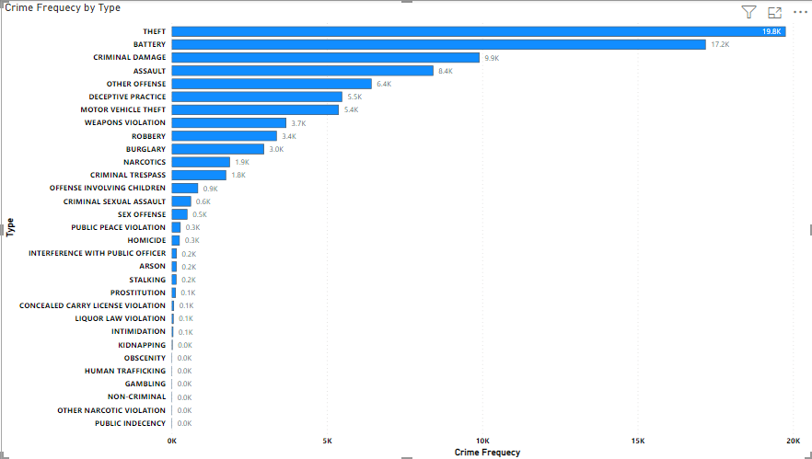

1. **Arrest Rate Evaluation: Analyze the percentage of reported incidents that have resulted in an arrest to gauge law enforcement effectiveness.**

**Answer: Arrest Rate evaluation:-**

* To calculate Arrest rate, first I calculate the total crime & total arrest by using DAX function count rows with filter.
* After calculating total crimes and total arrest, I use DAX function Divide to find out the percentage of reported incidents that have resulted in an arrest.
* **Formula:** Arrest Rate = DIVIDE ('crimes_data_2022 - crimes_data_2022'[Total Arrest],'crimes_data_2022 - crimes_data_2022'[Total Crime])* 100
* **Result:** 12.44
* **Visualization by:** Card

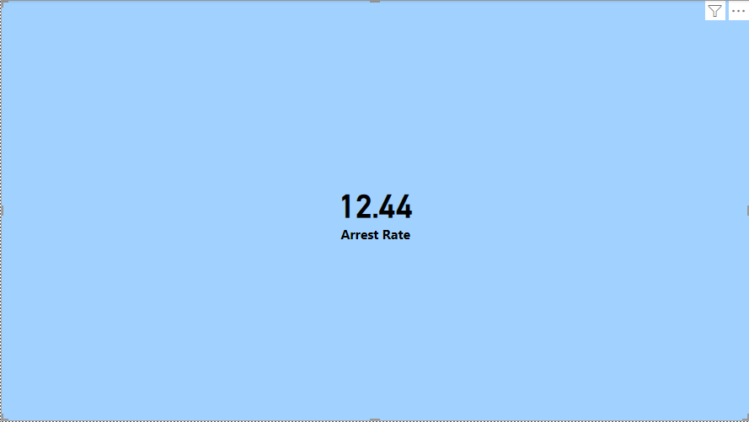

1. **District Crime Distribution Assessment: Calculate the number of crimes in each district to understand how crime is distributed across the city and identify high-crime areas.**

**Answer: District Crime Distribution Assessment:-**

* To find crime distribution in district, I uses table from visualization pane and put location description and count of id in column.
* **High Crime Areas:**
  1. District 6 – 5733 crimes
  2. District 8 – 5664 crimes
  3. District 4 – 5209 crimes

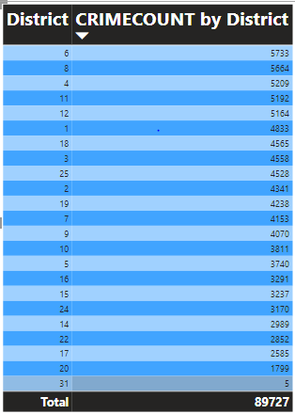

1. **How many categorical attributes are there in the data?**

**Answer:** There are total 7 categorical column present in the data such as Location description, Arrest, etc.Categorical attributes typically have a limited number of distinct values that represent categories or labels.

1. **Were there any Null values in the data, if there were how did you handle them? What is the ideal way to handle Null values?**

**Answer: Handling Null values:**

* Yes, null values are present in the dataset.
* We encountered null values, which are missing or undefined data points. In Power BI, we handled null values by either removing them from the dataset using filters or replacing them with appropriate values.
* The ideal way to handle null values is to carefully evaluate their impact on analysis and choose a method that preserves data integrity and minimizes bias.

1. **Domestic Crime Proportion Analysis: Analyze the ratio of domestic-related crimes to other types of crimes to understand the prevalence of domestic incidents.**

**Answer: Domestic crime proportion analysis:-**

* First, I created a measure domestic crime analysis using DAX formula.
* **Formula:** Domestic crime analysis = CALCULATE(COUNTROWS('crimes_data_2022 - crimes_data_2022'),'crimes_data_2022 - crimes_data_2022'[Domestic]=True)
* After that, I created another measure and calculate the Domestic crime ratio using DAX formula.
* **Formula:** Domestic Crime Ratio = DIVIDE([Domestic crime analysis],[Total Crime])
* **Result:** 0.20 Domestic crime ratio
* **Visualization by:** Card

1. **Is there any “Location Description” where the number of crimes is higher than expected? Come up with a table or visualization in which one can judge the frequency of crimes at each Location Description type.**

**Answer: Frequency of crime at each Location Description type:-**

* I use Table from visualization pane and put Location description and count of id in columns.
* **High crimes locations:**
  1. Street – 23039
  2. Apartment – 19022
  3. Residence - 12018

1. **What is the average time between reporting and solving a case as per the data?**

**Answer: Average time between reporting and solving a case:-**

* **First, I created a custom column using power query editor by using formula = Duration.From ([Updated On] - [Date]). Which created a column by counting difference between the crime date and solving date.**
* **Alternatively, we can use direct DAX formula to find the average time taken to solve the case.**
* **Formula:** Average time to Solve = AVERAGEX('crimes_data_2022 - crimes_data_2022','crimes_data_2022 - crimes_data_2022'[Updated On] - 'crimes_data_2022 - crimes_data_2022'[Date])
* **Result: 9 days**
* **Visualization by: Card**

1. **To reward the patrol officers, find the patrol area where the crimes reported were under control.**

**Answer: Patrol Area with low crime rate:-**

* To find the patrol area with low crimes, I created a table from visualization pane and put Beat and Count of ID in columns.
* **Patrol Area with low crimes:**

1. 1655 – 55 crimes
2. 1653 – 57 crimes
3. 1654 – 90 crimes.

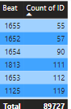

* According to the data the less crimes are commit in the patrol area 1655 , so we can award patrolling officer of beat area 1655 for his/her great work in controlling crimes.

1. **Did you create any calculated columns in this project? What is the difference between the ‘calculated column’ and ‘add column’ functions?**

**Answer:** No, I have created a custom column to find the duration of case solving.

In Power BI, both "Calculated Column" and "Add Column" functions are used to create new columns in your dataset, but they differ in how they operate and when they are applied.

* **Calculated Column:**
* Definition: A calculated column is a column that is calculated dynamically based on a DAX formula for each row in the dataset.
* Creation: You create a calculated column using DAX (Data Analysis Expressions) formulas directly within the Power BI Desktop interface.
* Application: Calculated columns are added to the underlying data model and are recalculated whenever the data is refreshed or filtered.
* Usage: Calculated columns are useful when you need to perform calculations based on existing columns in your dataset. For example, you might calculate profit margin, age from birthdate, or concatenate text fields.
* Impact on Performance: Calculated columns can have an impact on performance, especially in large datasets, as they are recalculated for each row during data refresh and can consume memory.
* **Add Column:**
* Definition: Adding a column using the "Add Column" function allows you to create a new column by transforming existing data in your dataset.
* Creation: You add a column using the Power Query Editor, where you can define transformations, perform data cleaning, or merge data from multiple sources.
* Application: Columns added using the "Add Column" function are part of the query editor process and are applied during the data loading and transformation phase, before the data is loaded into the data model.
* Usage: "Add Column" is useful when you need to perform data cleansing, transformation, or merge operations on your data before it is loaded into Power BI.
* Impact on Performance: Transformations applied using the "Add Column" function are typically more efficient than calculated columns, as they are applied during data loading and transformation, rather than during data refresh.

In summary, calculated columns are dynamic and calculated within the data model using DAX formulas, while columns added using the "Add Column" function are part of the data preparation process and applied using the Power Query Editor. The choice between the two depends on your specific data manipulation needs and performance considerations.

1. **Using ‘Calculate’ and a row iteration DAX function calculate the number of crimes which are of type ‘theft’ and happened in ‘District 8’.**

**Answer: Number of crimes in District 8 of type Theft:-**

* First, created a new measure and used DAX Formula.
* **Formula:** District 8 & Theft = CALCULATE (COUNTROWS ('crimes_data_2022 - crimes_data_2022'), FILTER ('crimes_data_2022 - crimes_data_2022','crimes_data_2022 - crimes_data_2022'[Type] = "Theft" && 'crimes_data_2022 - crimes_data_2022'[District] =8))
* **Result:** 1143 Crimes
* **Visualization by:** Card

1. **Using PowerBI, can you separate the Longitude and Latitude from the Locations Column (Longitude, Latitude)? Which feature will you use?**

**Answer:** Yes, we can easily separate Longitude and Latitude from location column. To do this task I used split column feature by delimiter.

1. **When we add a column in Power Query what’s the code that comes in M language in formula bar? What do you know about M-query?**

**Answer:** When we add a column in Power Query, the code that appears in the formula bar is written in the M language. M is the underlying language used in Power Query for data transformation and manipulation.

Overall, M-query is a powerful tool for data transformation and plays a central role in the self-service data preparation capabilities of Power BI and Excel.

**Subjective Question:**

1. **Is there any month-wise change in crime rates? If not, what could be the mistake in that operation?**

**Answer: Method:-**

* First, I created a line chart to see monthly trend of crimes. I put Date on X-axis and Count of IDs in Y-axis.
* After that, I analyze that there is clearly change in the crime rates monthly.
* In January, the crime rate is 15144 but in February, it is 14785, which conclude that crime rate decreases by 359 cases.
* In March, the observed crime rate is 17702, so we can say that in March the crime rate increases by 2917 cases against February.
* In April, the crime rate is 17447, which is low as compared to March by 255 cases.
* In May, the crime reported are 19322, which is all time high according to the data among all the previous month.
* In June, the crime rate is 5327, which is all time lowest according to the data.
* **Conclusion: -** By comparing analyzing the data, we can clearly see that there is changes in month wise data.
* **Visualization :** Line chart & Table

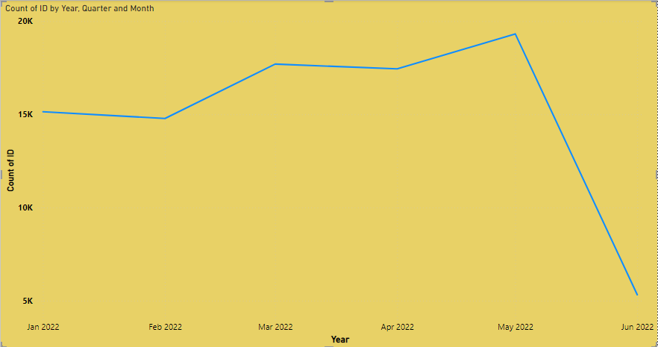

**Line chart to represent changes month wise**

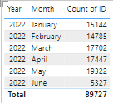

**Table to represent numbers of crimes reported month wise.**

1. **How can we reduce the no. of crimes, and which types of crime should we focus on to achieve improvement in the overall number of crimes?**

**Answer:**

* **After, comparing and analyzing the data we can see that Theft & Battery crime frequency are very high among all types.**

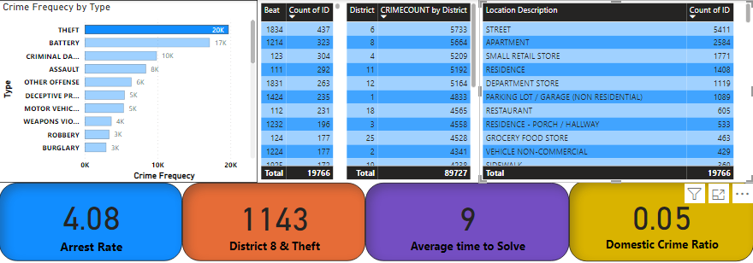

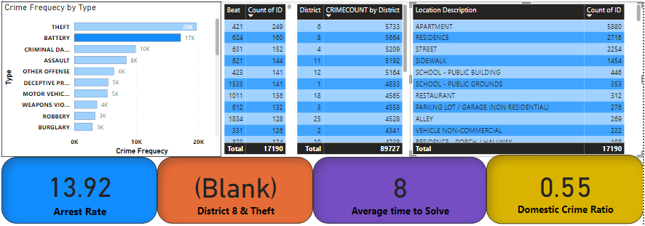

* **In addition, data gives insight that in District 6, 8, 4, 11 & 12 the crimes are almost equal to 6K.**
* **The location like Street, Apartment, Small Retail shop, Residence & Departmental store crimes committed are most. Street have almost 5K crime rate.**
* **In Patrolling area, 1834 & 1214 are high as compared to others.**
* **Area to focus & Improvement points to achieve overall improvement in crime rates.**
* To address high crime rates in specific areas and types of theft, such as those you identified in districts 6, 8, 4, 12, and 11, and in patrol beats 1834 and 1214, you can develop targeted interventions using a combination of law enforcement strategies, community engagement, and crime prevention initiatives. Here are some steps you can take:

1. **Increase Police Presence and Patrols:** Allocate additional resources and personnel to increase police presence in the identified high-crime areas and patrol beats.

Implement targeted patrols during peak crime hours and in areas with high theft rates, focusing on locations such as streets, apartments, small retail stores, residences, departmental stores, and sidewalks.

1. **Community policing and Engagement:** Foster strong partnerships between law enforcement agencies, community organizations, businesses, and residents to address theft and improve public safety.

Implement community-policing initiatives such as neighborhood watch programs, citizen patrols, and community meetings to empower residents and encourage collaboration in crime prevention efforts.

1. **Crime Prevention through Environmental Design (CPTED):** Implement CPTED principles to design and modify the physical environment in high-crime areas to deter theft and enhance safety.

Improve lighting, visibility, and surveillance in public spaces and high-risk areas to increase natural surveillance and reduce opportunities for crime.

1. **Targeted Enforcement and Investigations:** Conduct targeted enforcement operations and undercover investigations to disrupt theft networks and apprehend offenders.

Collaborate with other law enforcement agencies, task forces, and specialized units to target prolific offenders and organized crime groups involved in theft.

1. **Public Awareness and Education:** Launch public awareness campaigns to educate residents, businesses, and visitors about theft prevention strategies, including securing valuables, reporting suspicious activity, and utilizing security measures.

Provide resources and training to businesses on theft prevention techniques such as shoplifting prevention, employee training, and security measures.

1. **Data-Driven Decision-Making:** Continuously monitor and analyze crime data using Power BI to evaluate the effectiveness of interventions and identify emerging trends or shifts in crime patterns.

Use data insights to adjust strategies, reallocate resources, and prioritize efforts based on evolving crime dynamics and community needs.

By implementing targeted interventions tailored to the specific types of theft and locations identified in your analysis, you can work towards reducing crime rates and improving public safety in the identified high-crime areas and patrol beats. Collaboration, community engagement, and data-driven decision-making are key components of successful crime prevention efforts.Top of Form

1. **Which localities experience higher crime rates, and what measures can we ensure to reduce these numbers?**

**Answer:** As in the previous question we analyzes that the crime rates are higher in district number 6, 8, 4, 11 & 12 as compared to other districts.

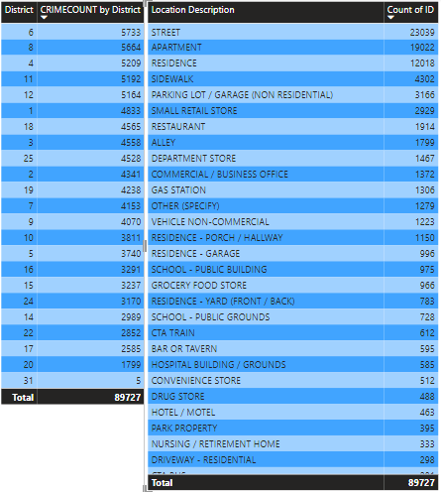

* Therefore, the above visual clearly stated that in the mentioned district at location street, apartments, residence & departmental stores are facing high crime rates as compare to others.
* **Measure to prevent crimes:-**

To address high crime rates in specific areas and types of theft, such as those you identified in districts 6, 8, 4, 12, and 11, and in patrol beats 1834 and 1214, you can develop targeted interventions using a combination of law enforcement strategies, community engagement, and crime prevention initiatives. Here are some steps you can take:

1. **Increase Police Presence and Patrols:** Allocate additional resources and personnel to increase police presence in the identified high-crime areas and patrol beats.

Implement targeted patrols during peak crime hours and in areas with high theft rates, focusing on locations such as streets, apartments, small retail stores, residences, departmental stores, and sidewalks.

1. **Community policing and Engagement:** Foster strong partnerships between law enforcement agencies, community organizations, businesses, and residents to address theft and improve public safety.

Implement community-policing initiatives such as neighborhood watch programs, citizen patrols, and community meetings to empower residents and encourage collaboration in crime prevention efforts.

1. **Crime Prevention through Environmental Design (CPTED):** Implement CPTED principles to design and modify the physical environment in high-crime areas to deter theft and enhance safety.

Improve lighting, visibility, and surveillance in public spaces and high-risk areas to increase natural surveillance and reduce opportunities for crime.

1. **Targeted Enforcement and Investigations:** Conduct targeted enforcement operations and undercover investigations to disrupt theft networks and apprehend offenders.

Collaborate with other law enforcement agencies, task forces, and specialized units to target prolific offenders and organized crime groups involved in theft.

1. **Public Awareness and Education:** Launch public awareness campaigns to educate residents, businesses, and visitors about theft prevention strategies, including securing valuables, reporting suspicious activity, and utilizing security measures.

Provide resources and training to businesses on theft prevention techniques such as shoplifting prevention, employee training, and security measures.

1. **Data-Driven Decision-Making:** Continuously monitor and analyze crime data using Power BI to evaluate the effectiveness of interventions and identify emerging trends or shifts in crime patterns.

Use data insights to adjust strategies, reallocate resources, and prioritize efforts based on evolving crime dynamics and community needs.

By implementing targeted interventions tailored to the specific types of theft and locations identified in your analysis, you can work towards reducing crime rates and improving public safety in the identified high-crime areas and patrol beats. Collaboration, community engagement, and data-driven decision-making are key components of successful crime prevention efforts.Top of Form

Top of Form

1. **Can you suggest wards where security improvements should be made to reduce crime?**

**Answer**: After, analyzing the data I found that the crimes are most occurred at ward number as mentioned below –

1. **Ward – 42:** In ward number 42, the crime rate is almost high as compared to others. The total crimes are 4595 are committed there.
2. **Ward – 27:** Ward 27 has second most high crime rates that is 4195.
3. **Ward – 28:** Ward 28 is ranked third in crime rates that is 3857**.**

* **Visualization By: Table**

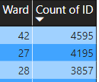

* To address high crime rates in specific areas and types of theft, such as those you identified in districts 6, 8, 4, 12, and 11, and in patrol beats 1834 and 1214, you can develop targeted interventions using a combination of law enforcement strategies, community engagement, and crime prevention initiatives. Here are some steps you can take:

1. **Increase Police Presence and Patrols:** Allocate additional resources and personnel to increase police presence in the identified high-crime areas and patrol beats.

Implement targeted patrols during peak crime hours and in areas with high theft rates, focusing on locations such as streets, apartments, small retail stores, residences, departmental stores, and sidewalks.

1. **Community policing and Engagement:** Foster strong partnerships between law enforcement agencies, community organizations, businesses, and residents to address theft and improve public safety.

Implement community-policing initiatives such as neighborhood watch programs, citizen patrols, and community meetings to empower residents and encourage collaboration in crime prevention efforts.

1. **Crime Prevention through Environmental Design (CPTED):** Implement CPTED principles to design and modify the physical environment in high-crime areas to deter theft and enhance safety.

Improve lighting, visibility, and surveillance in public spaces and high-risk areas to increase natural surveillance and reduce opportunities for crime.

1. **Targeted Enforcement and Investigations:** Conduct targeted enforcement operations and undercover investigations to disrupt theft networks and apprehend offenders.

Collaborate with other law enforcement agencies, task forces, and specialized units to target prolific offenders and organized crime groups involved in theft.

1. **Public Awareness and Education:** Launch public awareness campaigns to educate residents, businesses, and visitors about theft prevention strategies, including securing valuables, reporting suspicious activity, and utilizing security measures.

Provide resources and training to businesses on theft prevention techniques such as shoplifting prevention, employee training, and security measures.

1. **Data-Driven Decision-Making:** Continuously monitor and analyze crime data using Power BI to evaluate the effectiveness of interventions and identify emerging trends or shifts in crime patterns.

Use data insights to adjust strategies, reallocate resources, and prioritize efforts based on evolving crime dynamics and community needs.

By implementing targeted interventions tailored to the specific types of theft and locations identified in your analysis, you can work towards reducing crime rates and improving public safety in the identified high-crime areas and patrol beats. Collaboration, community engagement, and data-driven decision-making are key components of successful crime prevention efforts.Top of Form

1. **Crime Rate Trend Analysis: Monitor changes in crime rates over time to detect any discernible patterns or trends.**

**Answer: Method:-**

* First, I created a line chart to see monthly trend of crimes. I put Date on X-axis and Count of IDs in Y-axis.
* After that, I analyze that there is clearly change in the crime rates monthly.
* In January, the crime rate is 15144 but in February, it is 14785, which conclude that crime rate decreases by 359 cases.
* In March, the observed crime rate is 17702, so we can say that in March the crime rate increases by 2917 cases against February.
* In April, the crime rate is 17447, which is low as compared to March by 255 cases.
* In May, the crime reported are 19322, which is all time high according to the data among all the previous month.
* In June, the crime rate is 5327, which is all time lowest according to the data.
* **Conclusion: -** By comparing analyzing the data, we can clearly see that there is changes in month wise data.
* **Visualization :** Line chart & Table



**Line chart to represent changes month wise**



**Table to represent numbers of crimes reported month wise.**

* Crimes trended down, resulting in a 78.67% decrease between January 2022 and December 2022.
* Crimes dropped from 13,384 to 2,855 during its steepest decline between January 2022 and December 2022.

1. **Create a monthwise tabular data consisting of two columns, month and total no. of crimes in that month. Also, add one more column where each row of the column contains the total no. of crimes for the previous month. Do we need to use any filter-based DAX function here (All, All except, etc)?**
2. **As per the previous reports, most domestic crimes do not result in arrest due to public hesitation and family pressure is this trend visible in our data?**

**Answer:**

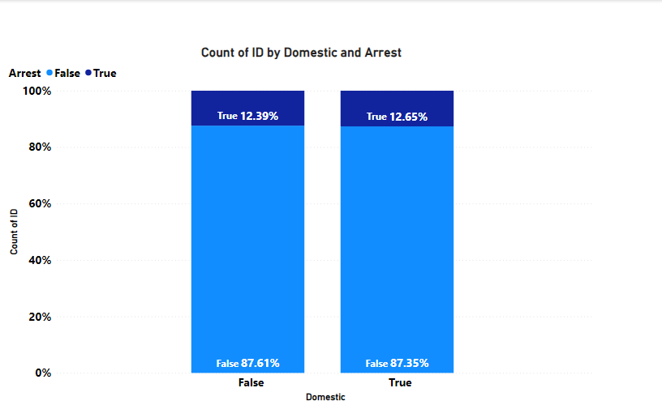

* As per the above visual, we can clearly see that only 12.65% of cases are result in arrest and rest of the 87.35% are not resulted in arrest.
* Therefore, we can say that the trend of not result into arrest in most domestic cases continues due to family pressure and public hesitation.

1. **Could you generate a visual representation that emphasizes the frequently occurring terms within the "Description" column?**

**Answer:**

* Yes, we can create visuals to find the most frequently occurring term in the column description.
* We can use words cloud as a visualization tool to find the most frequently occurring term.
* However, due to some circumstances, I am not able to get word cloud so; I created a bar chart to identify the most frequently occurring term.

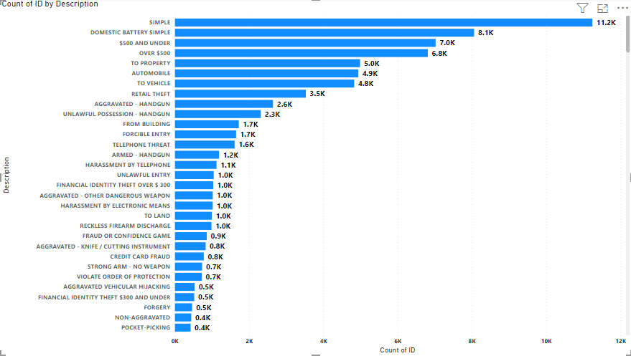

* As per the above visual, the most frequently occurring term in the column is “SIMPLE” with 11.2K occurrence.
* The term “DOMESTIC BATTERY SIMPLE” is second most occurring term in the column description.

1. **Are there any particular regions as per the data where the number of domestic crimes reported is very high?**

**Answer:**

* In the given data, there is no specific region is mentioned or there is no significance of region is there.
* However, there is district available in the dataset, which I can use to find particular region, or district where domestic crimes occurs most.

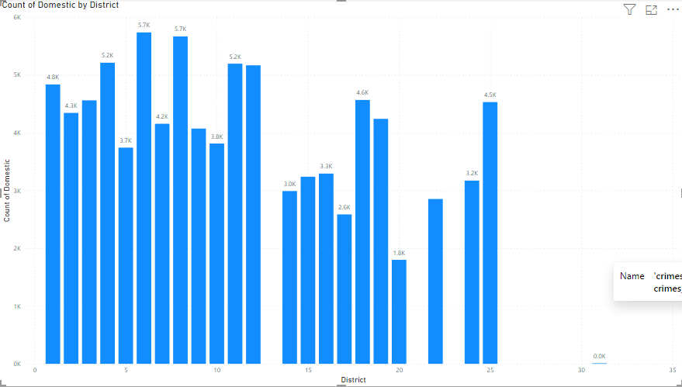

* According to the above visual, I have found some insight that are mentioned below:

1. District 6 has most domestic crimes about 1636 cases.
2. District 4 has 1445 domestic cases.
3. District 3 has 1296 domestic cases.
4. District 11 has 1250 domestic cases.
5. District 7 has 1235 domestic cases**.**
6. **Is the solving time of cases also dependent upon the type and locality of crime?**

**Answer:** To identify the relation between type and locality of crime by solving time, I do some steps:

* First, I have created a new measure named as average time to solve by using DAX function.
* Then, I created a matrix table in which I put location description in rows, type in columns and in values I place average time to solve the case.

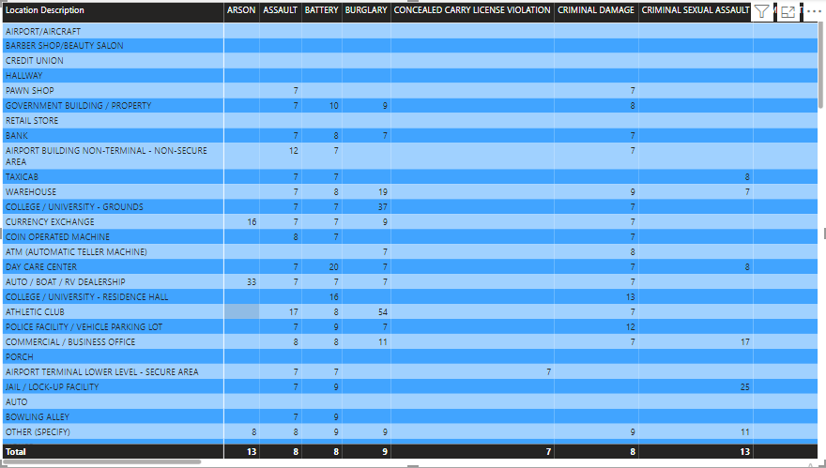

* After analyzing the matrix table, I found that the type and locality is not dependent on solving time.
* In different location, there is different solving time of same type. Therefore, we can say that there is no relation between type, locality and solving time.

1. **Create a calculated column to flag the domestic crimes that took place in District 8.**

* **Answer:** The calculated column is created in data model using data modelling tab using DAX formula.
* **Formula:** DomesticCrimesInDistrict8 = IF ('crimes_data_2022 - crimes_data_2022'[Domestic] = "True" && 'crimes_data_2022 - crimes_data_2022'[District] = 8, 1, 0).
* The calculated column flags domestic crimes that occurred in District 8 with a value of 1.
* Other crimes that do not meet these criteria are flagged with a value of 0 in the column.
* This column allows for easy analysis of domestic crime trends specifically in District 8.

1. **Out of all the types of crimes, which do you, think is the most dangerous one and rank the type of crimes according to their no. of occurrences?**

**Answer:**

* To do this task, I created a bar chart in which I put crime type in Y-axis and crime frequency in X-axis.



* By using this visualization, we can clearly see that the crime type theft are most committed crime according to the data with number almost 20K.
* After Theft, Battery and Criminal damage are most committed crime in the city.
* So, we can rank Top 5 as follow:

1. Rank 1 – Theft (20K)
2. Rank 2 – Battery (17K)
3. Rank 3 – Criminal Damage (10K)
4. Rank 4 – Assault (8K)
5. Rank 5 – Other Offence (6K)

* **Theft:** Theft is the unlawful taking of someone else's property with the intent to permanently deprive the owner of it. This can include various forms such as shoplifting, burglary, robbery, and motor vehicle theft.
* **Battery:** Battery is a criminal offense that involves the intentional and unlawful physical contact with another person without his or her consent, resulting in bodily harm or injury. It typically involves actions like punching, hitting, kicking, or otherwise physically assaulting someone.
* **Criminal Offense:** Criminal offense is a broad category encompassing a wide range of illegal activities or behaviors that are prohibited by law. This can include offenses such as drug possession, vandalism, fraud, weapons offenses, and many others.
* **Assault:** Assault refers to the intentional act of causing apprehension of harmful or offensive contact with another person. It may or may not involve physical contact, but the threat of harm or fear of harm is present. Assault can range from simple assaults, which involve threats or attempts to harm without physical contact, to aggravated assaults, which involve serious bodily injury or the use of a deadly weapon.
* Therefore, according to me Criminal offence and Battery are most dangerous one as they affect the person mentally and physically put bad impact on the society and culture of the country.

1. **What do you understand by PowerBI gateway? What are its use cases?**

**Answer:** Power BI Gateway is a component of the Power BI ecosystem designed to facilitate data refreshes and access to on-premises data sources for Power BI services. It acts as a bridge between on-premises data sources and the cloud-based Power BI service, enabling seamless data integration and connectivity.

* Here's a deeper understanding of Power BI Gateway and its use cases:
* **Data Refresh:** Power BI Gateway allows users to schedule and automate data refreshes for datasets stored in on-premises data sources, such as SQL Server databases, Oracle databases, SharePoint lists, and Excel files. By installing and configuring the gateway, users can ensure that their Power BI reports and dashboards are always up to date with the latest data from on-premises systems.
* **Direct Query:** Power BI Gateway supports Direct Query mode, which enables real-time data access to on-premises data sources without having to import the data into Power BI. This allows users to interact with and analyze large datasets stored on-premises directly from Power BI reports and dashboards.
* **Live Connection:** With Power BI Gateway, users can establish live connections to on-premises Analysis Services models and Power BI Report Server instances. This enables organizations to leverage their existing investments in on-premises BI solutions while still benefiting from the advanced visualization and collaboration capabilities of Power BI.
* **Data Protection and Security:** Power BI Gateway ensures secure data transfer between on-premises data sources and the Power BI service by encrypting data in transit using industry-standard protocols such as SSL/TLS. It also provides authentication mechanisms to control access to on-premises data sources and enforce security policies.
* **Hybrid Deployment:** Power BI Gateway supports hybrid deployment scenarios where organizations maintain a combination of cloud-based and on-premises data infrastructure. It enables seamless data integration and collaboration across both environments, allowing users to access and analyze data from anywhere.
* **Use Cases:** Some common use cases for Power BI Gateway include:
* Enabling scheduled data refreshes for reports and dashboards based on on-premises data sources.
* Facilitating real-time data access and analysis for large datasets stored on-premises.
* Connecting Power BI to on-premises Analysis Services models and Power BI Report Server instances.
* Integrating Power BI with existing on-premises BI infrastructure for hybrid deployment scenarios.
* Ensuring data protection and compliance while accessing on-premises data from the cloud.
* In summary, Power BI Gateway plays a crucial role in enabling organizations to leverage their on-premises data assets within the Power BI ecosystem, providing flexibility, scalability, and security for data integration and analysis.

1. **How would you approach this problem, if the objective and subjective questions were not given?**

**Answer**: If the Subjective question and objective question are not there, I will approach according to the problem statement.

* As in problem statement, it is ask that we have to decrease crime rates in the city as per the new operation with top performing cops.
* First, I will find out the area where the most crimes occurring and find out which type of cases are most occurring there.
* After analyzing the area, I will find the area where crime are very less and find best patrolling officer of that area.
* This approach will help to find out the best officer of less crimes area who are controlling crime rates with their efforts and will help other officers of high crimes area to implements good practices that they using in their area.

1. **If you are also given a table of districts-states with state_id, district_id and name, what would be the type of relationship between district of our data and district_id of new table?**

**Answer:**

The type of relationship between the district in your existing data table and the district_id in the new table of districts-states would typically be a "Many-to-One" or "Many-to-One (Lookup)" relationship.

**Here is why:**

**Many-to-One Relationship:** In this type of relationship, many rows in the existing data table (e.g., your crime data table) can be associated with a single row in the new districts-states table. This implies that multiple records in your crime data may belong to the same district in the districts-states table.

**Lookup Relationship:** The district_id in the new table acts as a lookup key for the district information. Each row in your crime data table likely contains a district_id that corresponds to a specific district in the districts-states table. By referencing the district_id, you can retrieve additional information (such as the district name) from the districts-states table.

When setting up the relationship between the two tables in Power BI, you would typically establish a Many-to-One relationship from the district_id column in your crime data table to the district_id column in the districts-states table. This relationship allows you to leverage the district information from the districts-states table in your crime analysis and visualizations, ensuring data integrity and consistency.

**Report:**

The department has asked for a dashboard with three tabs:

1. Main Tab
2. Locality Tab
3. Type Exploration Tab

* **Using the Main tab in the report,** the government should be able to review the decrease in crime numbers and the improvements resulting from special police operations. This tab should include a date slicer and a filter for the primary type of crime.
* **Using the Locality Tab,** police management and the head of operations should be able to identify the most common types of crime and the localities/wards where these crimes occurred. This tab should include slicers forward, date, and primary crime type.
* **Using the Type Exploration Tab,** the Special Cops team aims to examine the total number of domestic crimes and, from those, how many arrests were made by the district. Additionally, they want to identify the crime type with the highest number of arrests. Essentially, this tab will provide metrics to summarize the department's actions and the number of tasks pending. The tab should include slicers for a month and the primary crime type.

**Make sure that all the visualizations look decent and are placed in a proper order. There are different POCs (Point Of Contact) for each tab, so make sure you involve all the metrics that POC may look at in that tab along with those mentioned in the tab description.**

**​​After making the report on the Desktop ensure that it is published on the PowerBI service and use the hosted link for submission of the dashboard and mentioning on the resume.**